Monday Night Gridiron Club Membership / Message Form

Name: ____________________________ Email: ___________________________

2022 Gridiron Club Membership Options

Gold - $100
Silver - $50
Bronze - $25

With a paid membership your name will be listed as a Gridiron member in our 2022 Program Book. Name as it will appear in program (Ex: Smith Family): ____________________________________

2022 Program Book Personal Message/Well Wishes-$25
(Must be a MNGI Member to place a personal ad in the Program Book. If you have a financial
hardship please contact Kevin Munley (781) 686-3398.)

Dimensions of the ad are 2 ½ x 7 ½ and can include up to 4 lines of text and 1 or 2 pictures. Send the text you wish to include and any pictures via email to sscostello@comcast.net

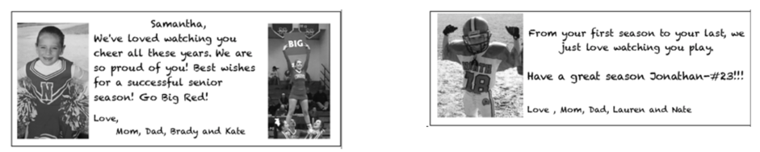

Total Order & Amount Due
Description | Qty | Cost | Total
Membership Dues |  | $100, $50 or $25
Personal Message |  | $25 – must be a MNGI member to place a personal ad in the program book
 |  | Total Amount Due | $

Payment Options: For Venmo – please include MNGI in the payment notes and your Name/Family Name as you’d like it to appear in the Ad Book.

Venmo | Check
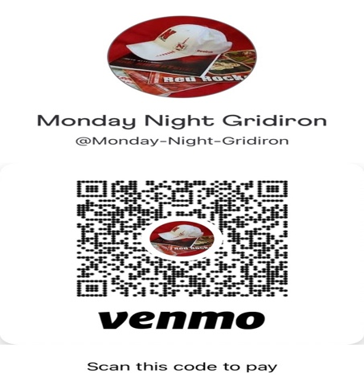 | Make checks payable to:  Monday Night Gridiron Club  PO Box 1382  Attleboro Falls, MA 02763

