GRIDIRON SENIORS OF THE WEEK
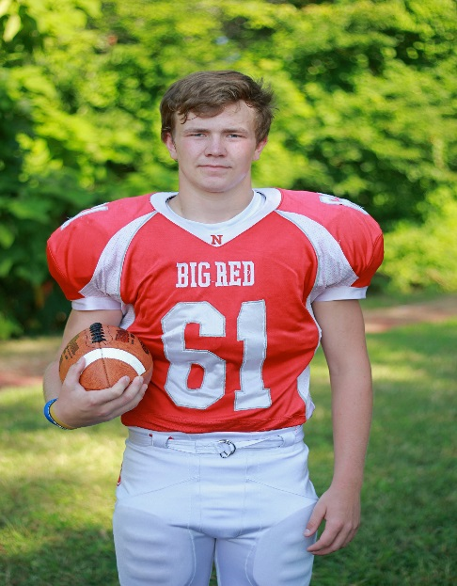  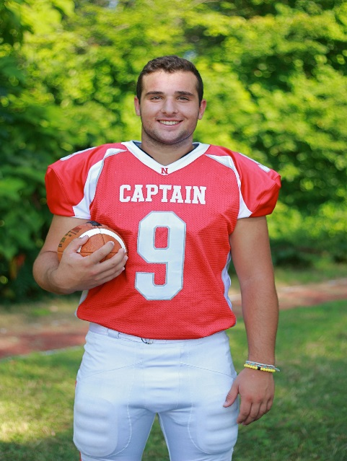 | Jack Puccio  10 Years Football  Sports Accomplishments – 2 Sport Varsity Letterman – Football and Lacrosse  Parents - Timothy & Tara  Siblings – Thomas & Julia  Favorite Football Moment – “35-0 victory over Duxbury at Community Field”  Post-Graduation Plans – Plans to Attend College – School & Major Undecided  Matthew Quinn  9 Years Football  Sports Accomplishments – 2 Youth Football Championships  Parent – Kevin  Siblings – Dianne & Joseph  Favorite Football Moment – “Beating Easton 28-0 in 8th grade”  Post-Graduation Plans – Attend 4 Year College and Major in Sports Management  Nicholas Raneri  11 Years Football  Sports Accomplishments – 2 Sport Captain – Played in 2 State Champioships in 1 Year  School Accomplishments – Honor Roll  Parents – Julie & Leo  Sibling - Anthony  Favorite Football Moment – “Playing at Gillette Stadium and beating Duxbury 35-0 in the playoffs”  Post-Graduation Plans – Play College Football

