GRIDIRON SENIORS OF THE WEEK
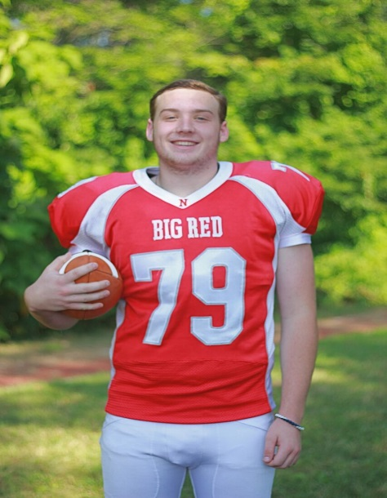  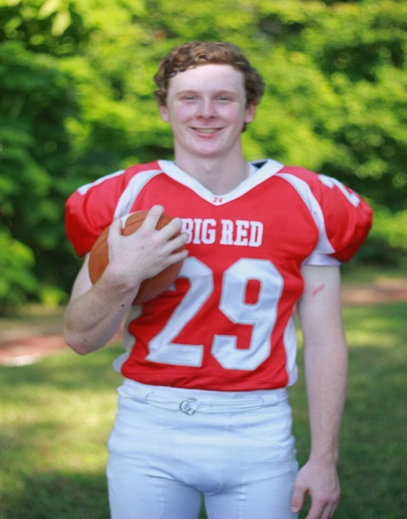  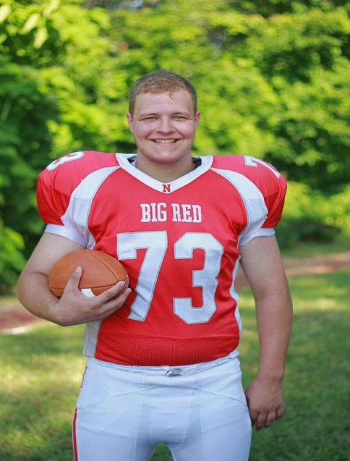 | Joe Larkin  11 Years Football  Sports Accomplishments – Playing in Superbowl at Gillette  School Accomplishments – Honor Roll  Parents & Family – John, Kathy & John  Favorite Football Moment – “Very 1st varsity play”  Post-Graduation Plans – Plans to go to College  Brendan McHugh  9 Years Football  Sports Accomplishments – 3 Sport Varsity Athlete – Football, Hockey (Captain) & Baseball. Hock Sports Football & Baseball All Star, Hock League & Sun Chronical Baseball All Star  School Accomplishments – National Honor Society, Honor Roll, Model Senate, Best Pals & Project Unite  Parents – Tom & Wendy  Siblings – Meghan & Alison  Favorite Football Moment – “Playing in the MIAA Div 3 Super Bowl at Gillette”  Post-Graduation Plans – Attend College & Study Political Science  John Nally  7 Years Football  Sports Accomplishments –Stealing a Base in a Baseball Game  School Accomplishments – Getting Good Grades  Parents – Kenneth & Jessica  Siblings – Patrick & Brandan  Favorite Football Moment – “Beating KP in the 1st Games of my senior year”  Post-Graduation Plans – Be Famous!

