GRIDIRON SENIORS OF THE WEEK
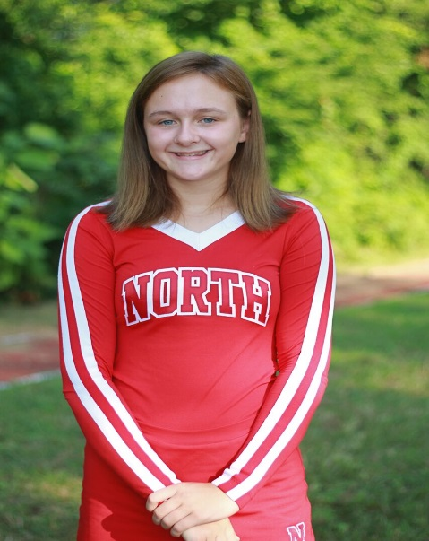  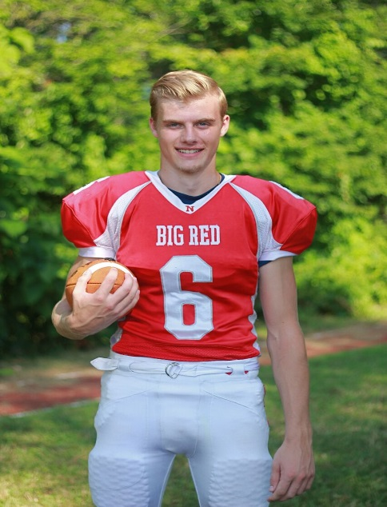  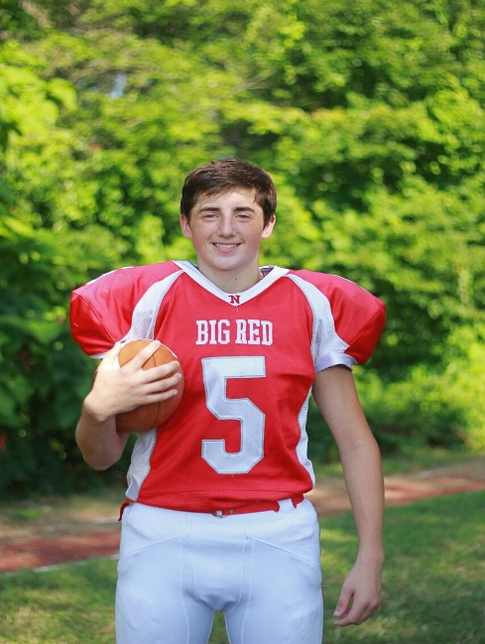 | Abigail King  5 Years Cheering  Sports Accomplishments – Won Grand Champs at Gameday 2016  School Accomplishments – Honor Roll  Parents & Family – Nicole, Brian, Angela, Nathan, Marissa & Meridith  Favorite Football Moment – “Performing at halftime of the football games”  Post-Graduation Plans – Plans to go to College majoring is Diagnostic Medical Sonography  Luke LaBonte  11 Years Football  Sports Accomplishments – Receiving Varsity Football Letter in 2017  School Accomplishments – NAHS Honor Roll  Parents – Dan & Maureen  Siblings – Jack & Rachel  Favorite Football Moment – “Playing in the MIAA Div 3 Super Bowl at Gillette Stadium – Scoring a TD on a QB Keeper for 79 yards vs Canton & Pop Warner Div III Championship”  Post-Graduation Plans – Attend College & Study Emergency Medical Services Management  Jared Lang  11 Years Football  Sports Accomplishments –4 Years Football & Track  School Accomplishments – NAHS Honor Roll & SADD  Parents – Ray & Maxine  Siblings – Danny, David & Jake  Favorite Football Moment – “MIAA Div 3 Super Bowl at Gillette Stadium & Interception on the Goal Line in Pop Warner to Help Save Undefeated Season”  Post-Graduation Plans – Attend College to Obtain Two Degrees in Secondary Education and History

