GRIDIRON SENIORS OF THE WEEK
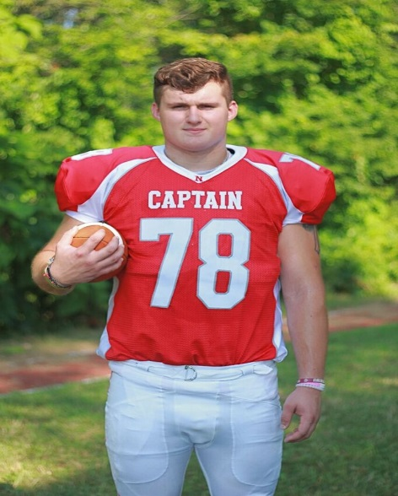 | Ryan Clemente  9 Years Football  Sports Accomplishments – Football Scholarship, 1st Team All State, Football  Capatin, Hockomock All Star & Hockomock Champs  School Accomplishments – Passing (So far)  Parents – Matt & Rebecca  Siblings – Tyler, Brodie, Reid & Austin  Favorite Football Moment – “Playing at Gillette and spanking Duxbury 35-0”  Post-Graduation Plans – Plans to play football at Sacred Heart University
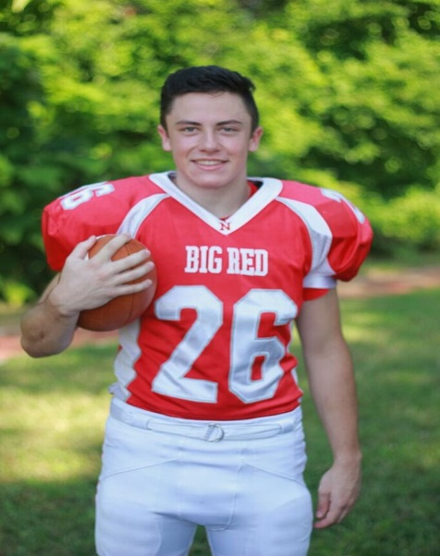 | Liam Conway  8 Years Football  Sports Accomplishments – Winter & Spring Track Captain & Winter Track State Champs  School Accomplishments – 4 Years Honor Roll  Parents – Michael & Wendy  Siblings – Chris & Matt  Favorite Football Moment – “Beating Duxbury last year”  Post-Graduation Plans – Attend College
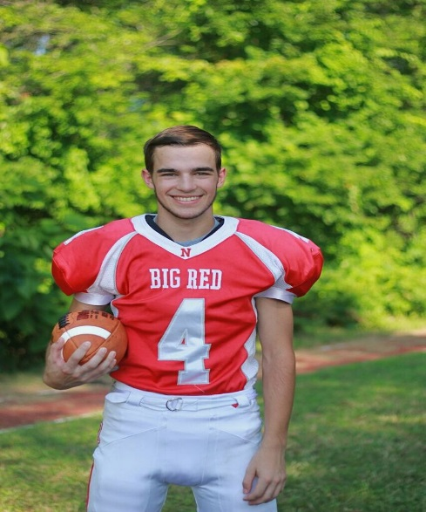 | Cameren Cornetta  4 HS Football & 8 Years NAJF  Sports Accomplishments – “When I earned my Varsity Letter”  Parents – Chris & Melissa  Sibling - Cirsten  Favorite Football Moment – “Beating KP in overtime to move on the Pop Warner playoffs”  Post-Graduation Plans – Pursue career as a firefighter/paramedic

